Notes on Lillsjöliden QA/QC for GLEON metab/catchment group

Jake Zwart; 2016-02-16

**QA/QC overview**

**METADATA**

*Lillsjoliden DO sensor depth* = 1 & 0.7 m – separate column in doobs.txt for depth

Ave Elevation = 317 m

*windHeight* <- 2.5m

*timeStep* <- 20 #number of minutes between DO measurements

*lat =*  63.845 #latitude of Lillsjöliden

**DO file**

No NA’s / missing data;

Range = 4.22-9.51 mg L-1

Possibly some sensor drift from buildup of algae etc.. during late July and again in mid-Aug.

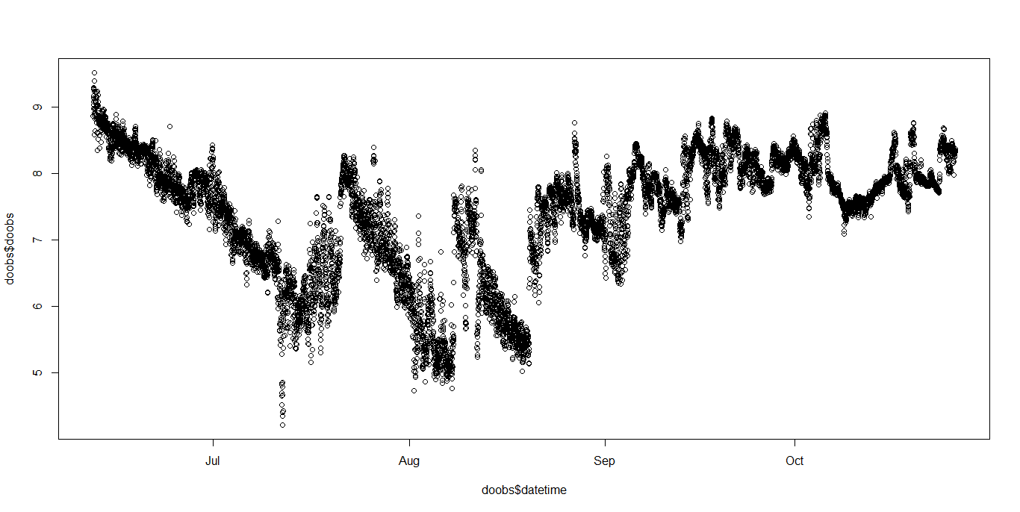

**Wind speed file**

No NA’s / missing data; no obvious anomalies. Two data sources used: see notes from Marcus: “Note, however, that some wind and PAR data had to be modeled based on respective data from neighboring sites.  
Most reconstructions are based on very strong regression models or are filling only very small gaps. For wind speed, however, I had to fill rather large gaps in the data, so I used a bootstrapped expectation-maximation algorithm using wind speed data from 3 other lakes in the area for gap-filling. this algorithm even allowed me to calculate confidence intervals for imputed values which I added as another column to the data requested. For details on the gap filling and other comments (e.g. discharge rating curves, logger depth), please read the readme_data_collection.xls-file in the attached zip-folder. Note also the details on DO logger calibration and maintenance I have already submitted via the google-form.”

Range = 0 – 4.28 m s-1

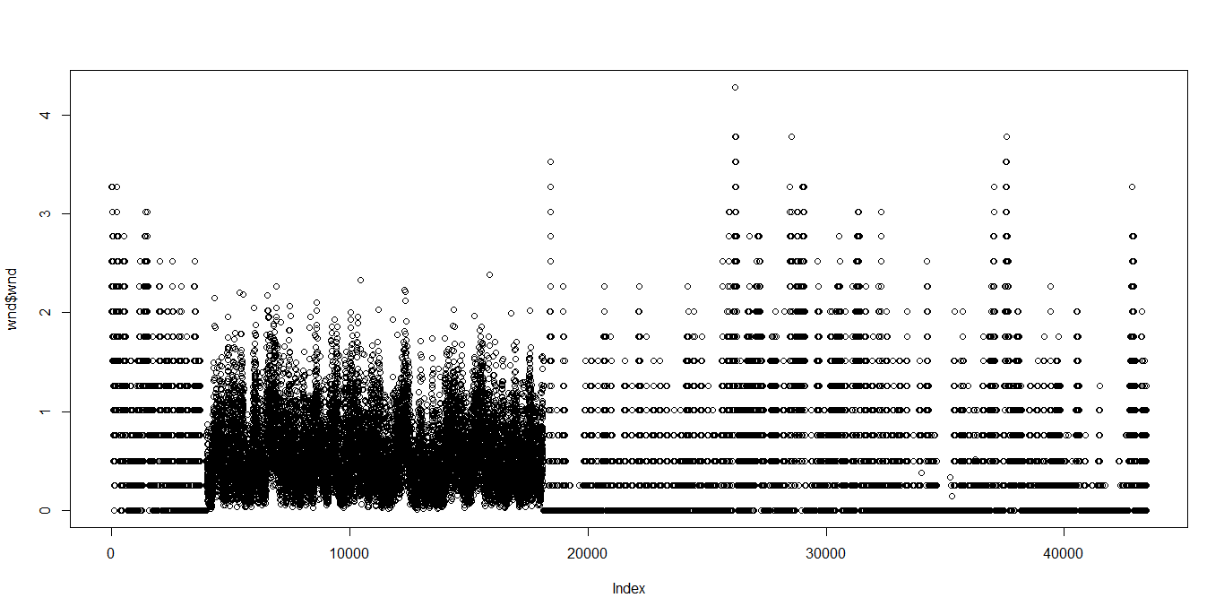

**PAR file**

No NA’s / missing data; no obvious anomalies

Range = 1.2 –2521.9 umol m-2 s-1 (1.2 is the minimum measurement from Onset light sensors – occurs at night)

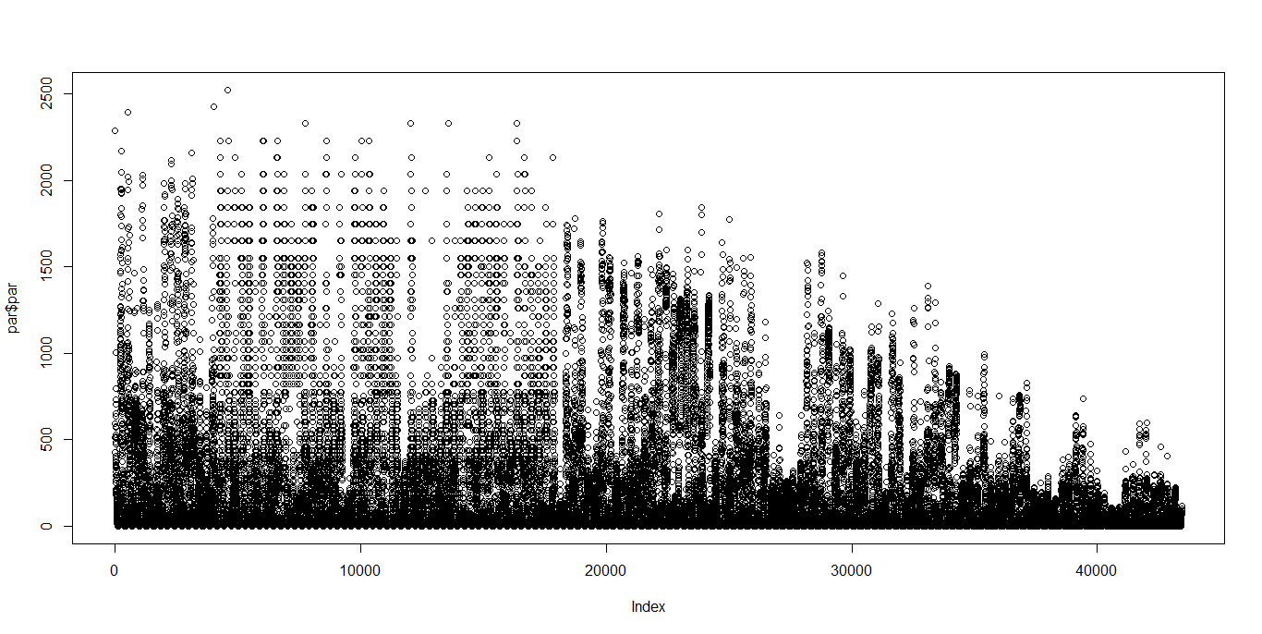

**Thermistor data file**

Some missing data (filled in as NA’s);

No obvious anomalies; surface water gets really cold at end of time series – possible ice cover??

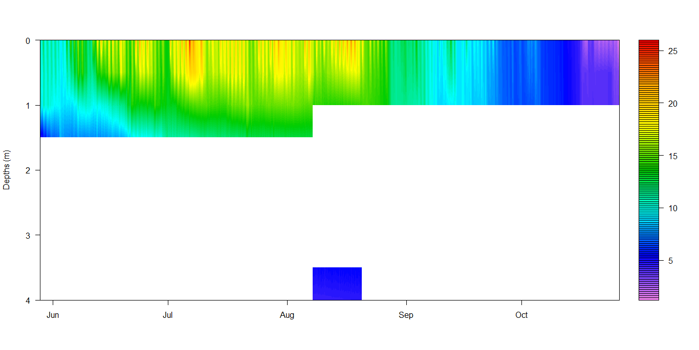

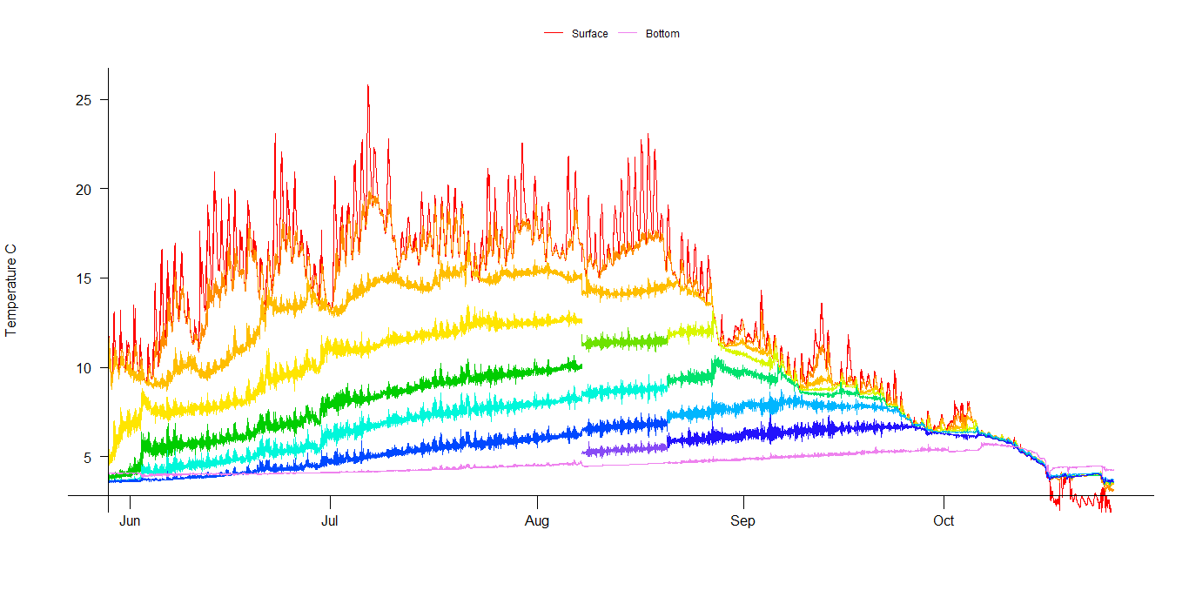

Heat map of thermistor profile